The SACM UML profile is created by extending meta element Class and Association from standard UML.

Base component

The base component of the SACM profile is Shown in F.1. In this component, the metaclass ***Class*** from the standard UML is imported and is generalized by Element of SACM, which is defined as a stereotype. Other elements of SACM are generalisations of Element and are also defined as stereotypes. The descriptions of the elements in SACM can be found in the specification.

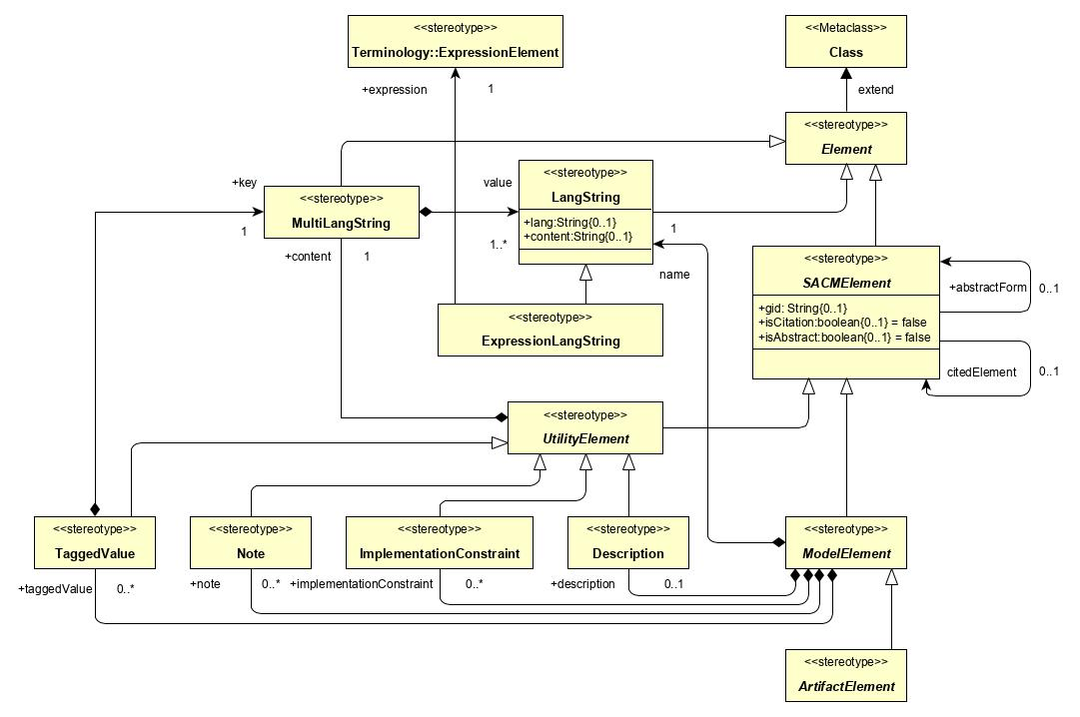

F.1 Base component of the SACM profile.

Assurance case component

The assurance case component of the SACM profile is Shown in F.2. In this component, all elements are defined as stereotypes, the descriptions of which can be found in the specification. In particular, stereotype *AssuranceCasePackage* is defined as a generalization of stereotype *ArtifactElement*, which is defined in the base component.

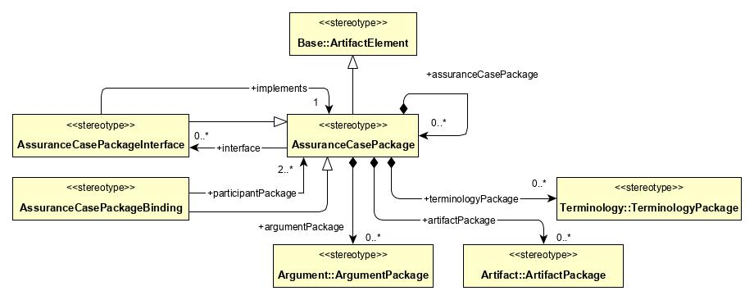

F.2 Assurance case component of the SACM profile.

Terminology component

The terminology component of the SACM profile is Shown in F.3. In this component, all elements are defined as stereotypes, the descriptions of which can be found in the specification. In particular, stereotype TerminologyElement is a generalization of stereotype ArtifactElement, which is defined in the base component.

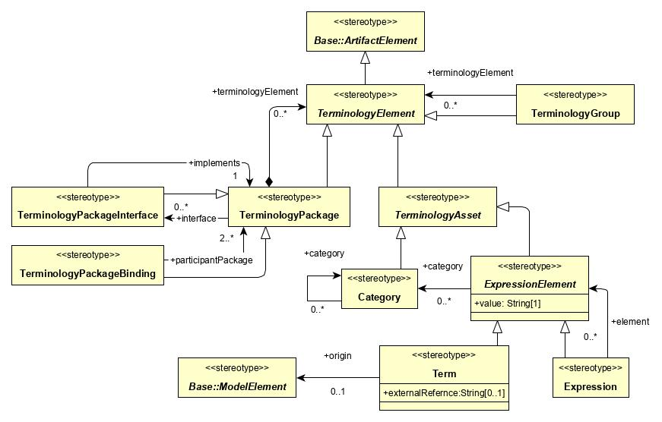

F.3 Terminology component of the SACM profile.

Argumentation component

The argumentation component of the SACM profile is Shown in F.4. In this component, all elements are defined as stereotypes, the descriptions of which can be found in the specification. In particular, stereotype ArgumentationElement is a generalization of stereotype ArtifactElement, which is defined in the base component. It is to be noted that stereotype *AssertedRelationship* does not import ***Association*** from the standard UML package, it is due to the fact that *AssertedRelationship* acts as an object in SACM’s concrete syntax, although it has a notion of source and target.

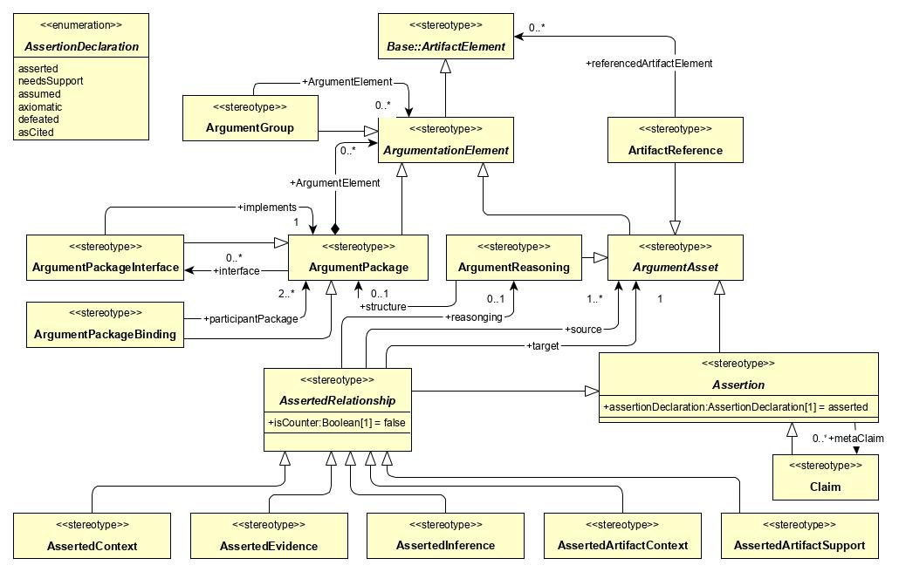

F.4 Argumentation component of the SACM profile.

Artifact component

The artifact component of the SACM profile is Shown in F.5. In this component, all elements are defined as stereotypes, the descriptions of which can be found in the specification. In particular, stereotype ArtifactElement is a generalization of stereotype ArtifactElement, which is defined in the base component. It is to be noted that stereotype *ArtifactAssertedRelationship* extends metaclass ***Association*** from the standard UML package, its defines additional source and target features which are both navigable.

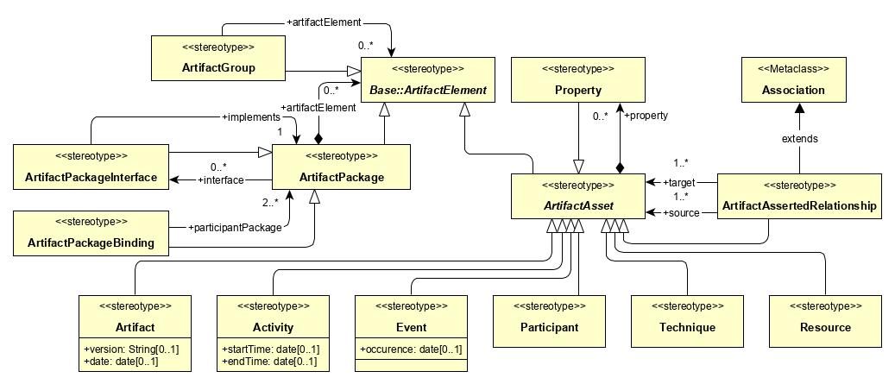

F.5 Artifact component of the SACM profile.